**User Manual**

**ProConnected Smoke Alarm with Base Station**

**Model: XS01-M + SBS50**

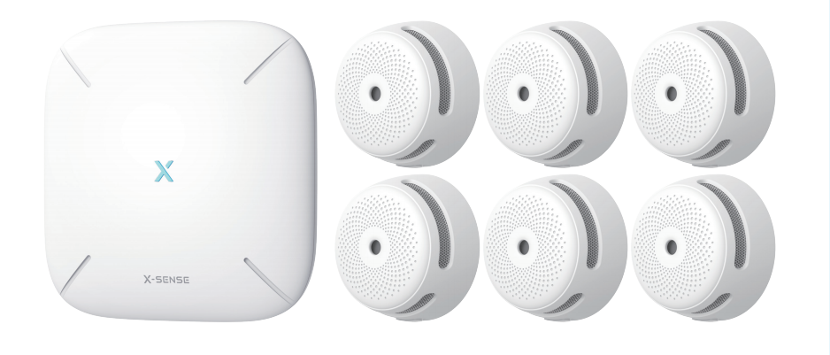

This user manual contains important information regarding the operation of your X-Sense smoke alarm. Ensure you read this user manual fully before installing and operating the alarm. If you are installing this smoke alarm for use by others, you must leave this manual (or a copy of it) with the end user.

#### Introduction

Thank you for purchasing our smoke alarm. The performance of this smoke alarm complies with the European standard EN 14604:2005 + AC:2008 and is designed to detect smoke.

This smoke alarm can be connected to the X-Sense SBS50 base station using the X-Sense Home Security app. After connecting to the base station, these alarms will be interconnected, so when one alarm is triggered, all will sound an alarm. Additionally, push notifications will be sent to your smartphone from the app, allowing you to know whether there is danger in your home so you can take immediate action. XS01-M smoke alarms can also be interconnected without being added to the base station.

X-Sense products are being improved and the product portfolio is constantly being expanded, so feel free to visit our website to take part in our news.

**Product Overview**

**XS01-M Smoke Alarm**

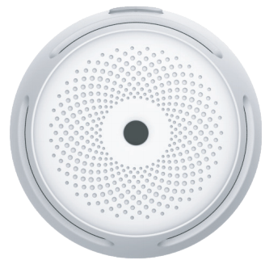

LED Indicator

Buzzer

Test/Silence Button

**SBS50 Base Station**

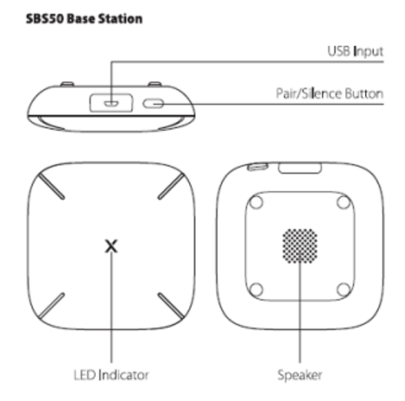

LED Indicator

USB Input

Speaker

Pair/Silence Button

#### Package Contents

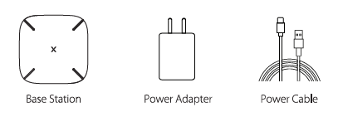

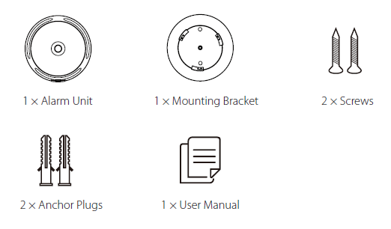

Smoke Alarm Unit

Mounting Bracket

Screws

Anchor Plugs

Batteries (Pre-installed)

Base Station

Power Adapter

Power Cable

User Manual

**Device Setup**

**Download the X-Sense Home Security App**



To download the **X-Sense Home Security** App, scan the QR code below or search for **“X-Sense Home Security”** in the Apple App Store or Google Play Store. Sign up with a valid email address. If you already have an account, make sure the app is updated to the latest version.

***Note: Make sure your smartphone supports iOS 11 and higher, or Android 8.0 and higher.***

**Before connecting devices, make sure that:**

1. You know your Wi-Fi network name and password.

2. You are connecting your base station and water leak sensor using a 2.4 GHz Wi-Fi network (incompatible with 5 GHz Wi-Fi network).

3. Make sure the Bluetooth on your phone is turned on.

***Note: When the device is configured via Wi-Fi, make sure your mobile phone and devices are as close to the router as possible, which can speed up device configuration.***

**Connect the Base Station to the Network**

1. Connect the base station to a power source with the power adapter.
2. Tap “Add Device” in the app, select “Base Station (SBS50)” in the product list, and then you will see the “Scan QR Code” page. Scan the QR code on the bottom of the base station.
3. Enter a name for the base station. Select the home you created or create a new home for the base station, then select the room in which it is installed. If you create a new home, you will need to enter a name and select the country or region in which you live.
4. Press and hold the pair button of the base station for 5 seconds until the LED indicator flashes yellow rapidly, indicating that the base station is waiting to connect to the Wi-Fi.

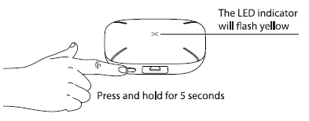

Press and hold for 5 seconds

The LED indicator will flash yellow

1. Tap “Operation confirmed” and click “Next.” The page will show “Searching for nearby Bluetooth devices.”
2. Enter the correct Wi-Fi and password then click “Next” to add the device. You will hear “connecting to Wi-Fi.”
3. After successfully connected, you will hear “Wi-Fi connected” and the “Device added” page will appear. The LED indicator will stay solid blue and you can find the base station in the device list.

**Connect the ProConnected Smoke Alarm to the Base Station**

The ProConnected Smoke Alarm connects to the base station through the wireless network. When the alarm is connected to the base station, you can receive push notifications wherever you are to stay informed of the device status, and to silence an alarm from your smartphone.

***Note: Before adding devices to the system, make sure the base station has been successfully added to the app.***

1. Tap "" and select "Smoke Alarms" working with SBS50 Base Station in the product list. Then, tap “Next” to enter the pairing page.
2. Follow the prompts on the page by pressing the test/silence button twice on the side of the smoke alarm until the red LED flashes rapidly, indicating that the device is waiting to connect to the Wi-Fi.
3. Tap “Next” to add the device. You will hear “Ready to add the device.”
4. After successfully connected, you will hear “Device added” and the “Device added” page will appear. Then you can find the smoke alarm in the device list.
5. If you want to add multiple devices into the system, please repeat the above steps

***NOTE: If you fail to add the smoke alarm to the network within 60 seconds, the device will automatically exit the network configuration. To re-enter the network configuration, you need to repeat the above steps.***

**Test the Device**

After you have successfully connected the smoke alarm to the base station, you will need to test the device to ensure it functions properly.

Briefly press the test/silence button and the alarm will beep 3 times continuously and the red LED will flash. After the test is completed, the sound will automatically stop. You can also go to the product homepage in the app, enter the Device Test page, then tap the Device Test button to test the device.

After the test is completed, an in-app message will appear and a push notification will be sent to your smartphone.

***Note: When the device is not connected to the app, press the test/silence button for more than 3 seconds, and the device will enter test mode.***

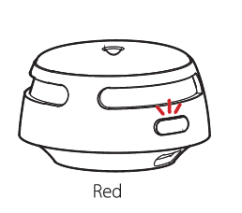

#### Interconnect

If you don’t want to add the smoke alarms to the base station, you can connect the smoke alarms using RF technology to create an interconnected alarm system. However, you will no longer be able to receive push notifications on your phone from the X-Sense Home Security app.

#### How to Set Up and Interconnect Wireless Alarms

XS01-M产品在不接入基站的前提下，可连入X-SENSE Link+产品中实现无线互联报警,属于X-SENSE Link+产品。

The wireless interlinked alarms contain a built-in RF module that enables you to wirelessly connect 2 or more interlinked alarms and create an interlinked network. When one unit is triggered, all interconnected alarms will sound. The X-Sense Link+ interconnect wireless alarms contain wireless interlinked smoke alarms, wireless interlinked carbon monoxide alarms, and wireless interlinked combination smoke and carbon monoxide alarms. This model is designed to be wirelessly interlinked with other X-Sense Link+ alarms, but is not designed to communicate with wireless interlinked alarms from other manufacturers.

**The XS01-M wireless interlinked alarms in one multi-pack have already been interconnected, and the alarms in each multi-pack have their own independent interlinked network.**

#### How to Interconnect

1. Make sure you only work with 2 units at a time, and make sure that they are both turned on to ensure successful connection.

**NOTE: To turn on XS01-M, pull out the battery insulating film from the battery compartment. To learn how to turn on different models of wireless interlinked alarms, please refer to their specific user manuals for more details.**

1. Quickly press the test/silence button on one of the 2 units 4 times; it will beep once and the red LED will flash slowly, indicating it has entered pairing mode and is waiting for a new unit to be added. Quickly press the test/silence button on the other unit twice; it will beep once and the red LED will flash rapidly, indicating it is searching for a device to connect to.
2. After the search is successful and an interconnected group is created, both units will beep once and automatically exit the interconnection mode. At this point, both units will only flash once 60 seconds, indicating they are in normal standby mode.
3. If you want to connect a third alarm to this group, first activate a new device by pulling out the battery insulating film, then quickly press the test/silence button on either of the 2 previously interconnected units 4 times. This unit will beep once, and the red LED will flash slowly, indicating it is ready to add a new device to the network. Next, quickly press the test/silence button on the new unit twice, and the red LED will flash rapidly, as it searches for a network to connect to. After the third unit successfully joins the interconnected network, both units will beep once and automatically exit the interconnection mode.
4. If you want to connect more units, simply repeat step 4. Up to 24 alarms can be interconnected this way. **To ensure that all alarms enter the same interlinked network, make sure you only work with 2 units at a time—one unit enters the pairing mode and the other unit enters the searching mode.**
5. Test the alarms according to the steps in the section “Alarm Test”.

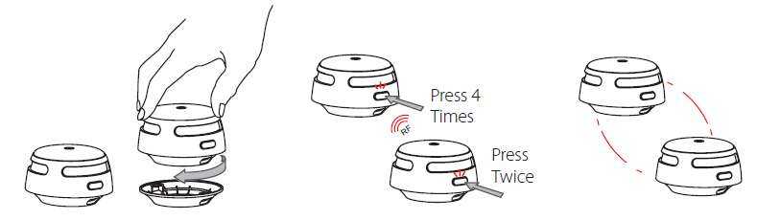

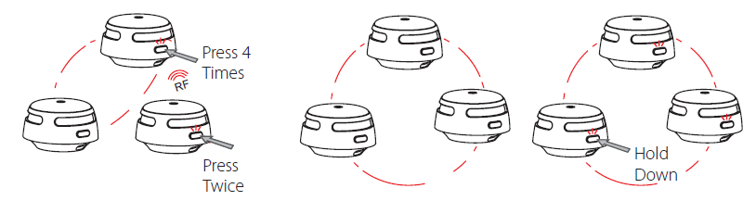

Quickly press 4 times

Quickly press twice

RF

Hold down the test/silence button

***NOTES***

1. ***The alarm will enter the searching mode or the pairing mode for 60 seconds with the red LED flashing. After 60 seconds, repeat step 2 to connect the alarms. If needed, press the test/silence button once while the alarm is in the searching mode or the pairing mode, and the red LED will stop flashing and the alarm will quit the pairing mode to enter normal status.***
2. ***Test all wireless alarms to ensure they are interconnected before installation.***
3. ***A maximum of 24 wireless alarms can be interconnected on the same network.***
4. ***The model can only be interconnected with other X-Sense*** ***Link+ wireless interlinked alarms.***

**How to Disconnect**

Quickly press the test/silence button 4 times; the smoke alarm will beep once. Then, hold down the button until it beeps once more to disconnect. After disconnecting, it can be reconnected to the same network, or added to a new network.

***NOTE: The X-Sense Link+ wireless interlinked alarms in one multi-pack have already been interconnected.***

#### Alarm Test

Be sure to test your alarms when you turn them on for the first time, or when the group configuration has changed. In addition to the weekly tests you should perform, it is recommended to test the alarm after returning from a long trip or vacation.

If your X-Sense XS01-M smoke alarm is interconnected to other X-Sense wireless alarms, we recommend that every individual alarm is tested during the weekly test.

|  |  |  |
| --- | --- | --- |
|  | **Test a single alarm** | **Test all interconnected alarms** |
| Action | Press the test/silence button. | Hold down the test/silence button. |
| Indication | * The alarm will beep 3 times every 4 seconds. * The red LED will flash during the audible signal. * After testing, the alarm will automatically enter standby mode. | * The initiating unit will beep continuously with the red LED flashing. * Other interconnected alarms in the network will receive the signal after 5 seconds, then they will beep continuously with the LED flashing red and green successively（XS01-M flashing red LED flashing）. Release the test/silence button and all the smoke alarms will stop testing. * The testing of the units should be completed within 3 minutes. * After testing, the units will automatically enter standby mode. |

***NOTE:***

***1.* Test all interconnected alarms** 仅仅适用不接入基站，产品自身互联的情况下使用。

***2. The test function accurately tests the alarm’s smoke sensing circuit without the need to test with smoke. If your smoke alarm fails to give an audible test signal, please refer immediately to the troubleshooting guide at the end of this manual. Never use an open flame to test this device.***

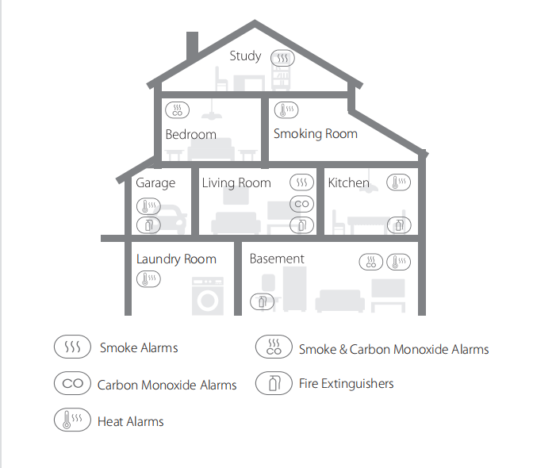

***NOTE: If a smoke alarm is installed in a kitchen, ensure it has an accessible silence button, and install it as far away from the stove and sink as possible to avoid false alarms.***

1. Prioritize the installation of an alarm in the bedroom and hallways, and make sure you can hear the alarm from all sleeping areas. In a home with several bedrooms, install an alarm in every bedroom. If you install only one smoke alarm in your home, install the alarm near to all bedrooms where possible, and not in a basement or furnace room.
2. Install an alarm above the stairway and on every floor of the house.
3. Smoke, heat and anything burning will spread horizontally after rising to the ceiling, so install the alarm in the middle of the ceiling where possible. Ensure that the alarm is installed at the minimum distance away from corner.
4. If an alarm cannot be installed in the middle of a ceiling, install it at a distance of 20 inches (50 cm) away from the corners of the room.
5. If an alarm is installed onto a wall, a distance of 4-12 inches (10-30 cm) should be kept below the ceiling.
6. If the length of a room or hall is beyond 900 cm (30 feet), several alarms should be installed in the same room.
7. When the wall or ceiling is angled, the alarm needs to be installed within 3 feet (90 cm) of the highest wall or ceiling point (measured horizontally) in the room.
8. In multi-level houses or apartments, install at least one wireless smoke alarm on each level and keep them installed in a straight vertical line (see diagram) with as few obstacles between each of the interconnected alarms as possible to ensure optimal signal transmission.

**Locations to Avoid:**

1. Near large metal surfaces and/or bundles of wire.
2. Near fluorescent lights, amateur radios, electrical equipment, or other devices that may transmit an RF signal, as electronic “noise” may cause nuisance alarms.

**WARNING!**

1. THIS ALARM SHOULD BE INSTALLED BY A COMPETENT PERSON.
2. ALARMS SHOULD NOT BE USED AS A SUBSTITUTE FOR PROPER INSTALLATION, USE AND MAINTENANCE OF FUEL BURNING APPLIANCES INCLUDING APPROPRIATE VENTILATION AND EXHAUST SYSTEMS.
3. TO PREVENT INJURY, THIS DEVICE SHOULD BE SECURELY ATTACHED TO THE CEILING OR WALL IN ACCORDANCE WITH THE INSTALLATION INSTRUCTIONS.
4. BATTERIES SHOULD NOT BE EXPOSED TO EXCESSIVE HEAT SUCH AS DIRECT SUNLIGHT, FIRE, ETC.

**Installation Method**

***NOTE: Before installation, it is recommended to test the interconnected alarms in the rooms where you intend to install them to ensure that they are within transmission range and that nothing will interfere with their communication.***

1. Use the mounting bracket to mark the screw holes on the ceiling or the wall.
2. Drill holes at the 2 marks using an appropriately-sized drill bit. Insert the anchor plugs and screw the mounting bracket using the screws provided.
3. Attach the alarm to the mounting bracket and turn clockwise to lock the alarm.
4. Test the alarm according to the steps in the section “Alarm Test”.

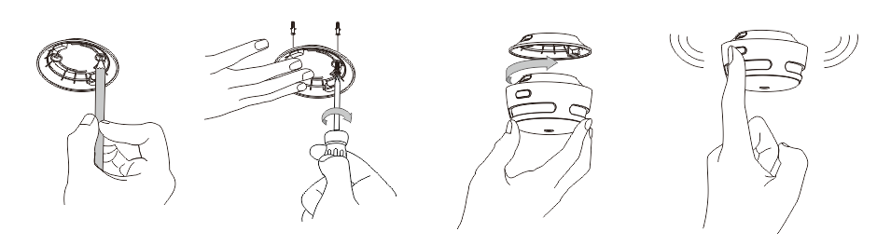

**Battery Replacement**

1. To replace the battery, detach the smoke alarm from the mounting bracket by twisting counterclockwise.
2. Pull the battery removal tab to remove the battery, and then install a new battery, matching the correct polarity markings.
3. Test the alarm, and then mount the alarm onto the mounting bracket by twisting clockwise to lock the alarm.

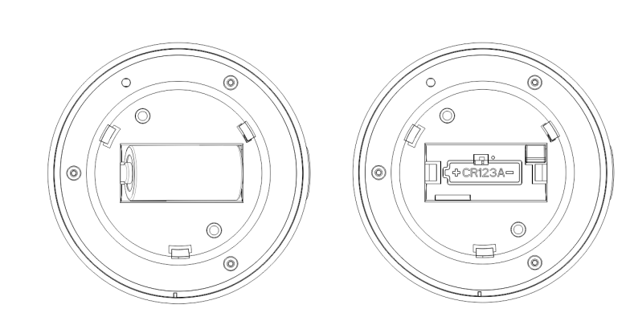

#### LED Indicator and Audible Alarm

**Alarm sounder**

**Green, Red & Yellow LED**

|  |  |  |  |  |
| --- | --- | --- | --- | --- |
| **Status** | | **LED Indicator** | **Audible Alarm** | **Action** |
| Standby Mode | | Red LED flashes once every 60 seconds. | None |  |
| Alarm Mode | Unit detects smoke and initiates an alarm. | Red LED flashes 3 times every 4 seconds. | 3 quick beeps every 4 seconds. | Dangerous smoke concentration is detected. Open nearby windows and doors, and immediately move to fresh air. |
| All other interconnected units in the network. | Red LED flashes 3 times every 4 seconds | 3 quick beeps every 4 seconds. | Dangerous smoke/CO concentration is detected by the initiating unit in the network. Please find the initiating unit and take action. |
| The LED flashes red 4 times, then the green LED flashes once every 5.8 seconds. | 4 quick beeps repeating every 5.8 seconds. | Dangerous CO concentration is detected by the initiating unit, and has reached the alarm status.  Please find the initiating unit and take action. |
| Unit detected smoke and initiated an alarm. | Red LED flashes once every second for 5 seconds. | None. | Alarm cancellation: When the smoke concentration level drops below the alarm threshold, the alarm signal will stop. Then, the alarm goes back to the  standby mode. |
| Test Mode | Test a single unit. | Red LED flashes 3 times every 4 seconds. | 3 quick beeps every 4 seconds. | 1. Press the test/silence button on the device.  2. Tap the Device Test button on the app (for devices connected to the base station).  Note: The devices that are connected to the base station can only be tested individually. |
| Test all interconnected units. | Red LED flashes 3 times every 4 seconds. | Continuous beeping until you release the test/silence button. | Initiating unit.  Hold down the test/silence button on one unit in the network. |
| The LED flashes red and green sequentially.  (XS01-M flashing red LED flashing) | Other interconnected alarms in the network. |
| Silence Mode | | Red LED flashes once every 5 seconds. | None | After 9 minutes, the unit will exit silence mode. |
| Low Battery | | Red LED flashes once every 60 seconds. | 1 beep every 60 seconds | Each alarm gives an independent warning. |
| Malfunction | | Red LED flashes twice every 60 seconds. | 2 beeps every 40 seconds | Each alarm gives an independent warning. |

**Alarm Mode**

**Interconnected System When Connected to the Base Station**

1. **If the Initiating Unit Is Triggered by Smoke:**

When one smoke alarm is triggered in the interconnected network when connected to the base station, the XS01-M unit will beep 3 times every 4 seconds, paired with the red LED flashing. Any other units (including smoke/CO alarms) will follow suit—they will beep 3 times every 4 seconds, paired with the LED flashing red and green in succession (XS01-M flashing red LED flashing).

在连入基站的模式下，An in-app message will appear and an alarm push notification will be sent to your smartphone.

When the smoke concentration level drops below the alarm threshold, the alarm will cease.

1. **If the Initiating Unit Is Triggered by CO:**

When one CO alarm is triggered in the interconnected network, the unit will beep 4 times every 5.8 seconds, paired with the LED flashing red. Any other units (including smoke/CO alarms) in the network will follow suit—they will beep 4 times every 5.8 seconds, paired with the LED that flashes red 4 times first, followed by the LED that flashes green once with every beep(XS01-M flashing red LED flashing).

在连入基站的模式下，An in-app message will appear and an alarm push notification will be sent to your smartphone.

When the CO concentration level drops below the alarm threshold, the alarm will cease.

***Notes:***

1. ***In the case that the base station powers off and is disconnected from the network, all devices are still interconnected, so when one alarm is triggered, all will go off.***
2. ***When one alarm is triggered, the base station will sound an alarm simultaneously and it will automatically mute after 10 minutes of continuous alarm. After the base station stops the alarm, all devices in the interconnected system will still alarm.***
3. ***When one unit is triggered, other interconnected units will sound. If the smoke alarm and CO alarm are triggered in the network at the same time, the alarm signal of the smoke alarm will take priority over that of the CO alarm.***

**Silence Mode**

You can mute the device by pressing the test/silence button on the device or the silence button in the app.

If you press the silence button during an alarm state, the unit will be in the silence mode for 9 minutes. During the silence mode, the red LED will flash once every 5 seconds. The alarm will enter the normal mode after 9 minutes.

**When Connected to the Base Station**

You can turn off the base station and all interlinked alarms when smoke is detected by pressing the Silence button on the base station or by tapping the Silence button in the app.

You can tap the Locate button in the app to find the initiating alarm; all devices will stop alarming except the initiating alarm. Simply silence the initiating alarm by tapping the mute icon in the app or by pressing the test/silence button on the device.

**When Not Connected to the Base Station**

Simply press the test/silence button on one of the devices to silence the interconnected system, however only silencing the initiating alarm will silence all other interconnected alarms.

***NOTES***

* ***You can silence all interconnected units by pressing the test/silence button on one of the units. If one unit is still alarming, it is the initiating unit (the unit that detected danger); to silence all interlinked units, you must also press the test/silence button on the initiating unit.***
* ***While interconnected, the initiating unit cannot be triggered again during the 9-minute silence duration. However, all other interconnected units can be triggered again if they detect danger during the silence mode.***

**Technical Specifications**

**Specifications of Base Station**

|  |  |
| --- | --- |
| Model | SBS50 |
| Power Supply | Input:100–240 V AC 50/60 Hz; Output: 5.0 V1.0 A |
| Safety Standard | EN 14604:2005+AC:2008 |
| Operating Temperature | 40–100°F (4.4–37.8°C) |
| Operating Relative Humidity | 0–85% RH (non-condensing) |
| Alarm Volume | 100 dB |
| App | X-Sense Home Security (both Android and iOS supported) |
| Wi-Fi Frequency | 2.4 GHz (Incompatible with 5 GHz Wi-Fi network) |
| Operating Frequency | 915 MHz (US)/868 MHz (EU) |
| Wi-Fi Transmission Range | 164 ft (50 m) |
| Wireless Protocol | IEEE 802.11b/g/n |

**LED Indicator**

|  |  |
| --- | --- |
| **Status** | **LED Indicator** |
| Powering on | The LED flashes red once. |
| Wi-Fi connected successfully | The LED remains solid blue. |
| Failed to connect to the Wi-Fi | The LED remains solid yellow. |
| Wi-Fi pairing mode | The LED flashes yellow. |
| Alarm | The LED flashes red. |

**Specifications of Smoke Alarm**

|  |  |
| --- | --- |
| Model | XS01-M |
| Power Supply | Replaceable 3V CR123A lithium battery |
| Battery Life | 5 years |
| Sensor Type | Photoelectric |
| Safety Standard | EN 14604:2005+AC:2008 |
| Operating Temperature | 40–100°F (4.4–37.8°C) |
| Operating Relative Humidity | ≤ 85% RH (non-condensing) |
| Alarm Loudness | ≥ 85 dB at 10 ft (3 m) @ 3.2 ± 0.3 kHz pulsing alarm |
| Silence Duration | About 9 minutes |
| Operating Frequency | 868 MHz |
| Maximum Number of Interconnected Units | 24 wireless units (only compatible with X-Sense wireless alarms) |
| Connection Distance (in open air) | 1,640 ft (500 m) |

***NOTES***

1. ***Battery life is calculated on the current ratings in the standby mode with weekly testings. If its operation mode changes to an alarming condition, the battery life will be decreased accordingly.***
2. ***The smoke alarm functions between 4.4 and 37.8°C (40 and 100°F). Prolonged exposure to temperatures outside of this range can reduce battery life and affect accuracy. We do not recommend operating the device outside of this range.***

**Maintenance**

To keep your smoke alarm in good working order, follow these simple steps:

1. Verify the unit’s alarm sound and indicator are working properly by testing the unit once a week.
2. As a minimum your smoke alarm should be cleaned once every 3 months: Remove the unit from the ceiling and clean the alarm cover and vents with your vacuum cleaner fitted with the soft brush attachment to remove dust and dirt.
3. Never use detergents or other solvents to clean the unit.
4. Avoid spraying air fresheners, hair spray or other aerosols near the alarm.
5. Do not paint the unit. Paint will seal the vents and interfere with the sensor’s ability to detect fire.
6. Never attempt to disassemble the unit or clean inside. Doing so will void your warranty.
7. When removed, place the smoke alarm back in its proper location as soon as possible, to assure continuous protection from fire.
8. When household cleaning supplies or similar contaminants are used, the area should be ventilated.

**Troubleshooting**

|  |  |  |
| --- | --- | --- |
| **PROBLEM** | **CAUSE** | **SOLUTION** |
| The device is not triggered when it is tested with smoke. | The smoke is not reaching the sensor properly. | The smoke needs to enter the smoke sensor from the metal mesh on the side to trigger the device. |
| The time duration is insufficient for the device to detect smoke. | Continuous smoke is necessary for the device to be triggered. When smoke reaches the smoke sensor, the device will be triggered in about 20 seconds. |
| The smoke concentration is low. | Sufficient smoke concentration is required for the smoke alarm to detect smoke. The greater the smoke concentration is, the faster the alarm will respond. |
| The device does not sound during testing. | The device does not turn on. | Please ensure the battery insulating film is removed and the device is turned on. If the battery runs out, replace the battery immediately. |
| You don’t push the test/silence button firmly. | Make sure you push the test/silence button firmly. |
| The device is improperly installed. | Check the installation positioning. The wireless signal might be blocked or out of range. |
| The app push notification is delayed or there are no push alerts. | The app push notification permission is disabled. | Turn on the push notification permission on the phone. |
| The base station is not within the network coverage of the router. | The distance between the base station and the router should be within 164 ft (50 m). Please ensure that the base station is always within the network coverage of the router. |
| The communication between the smoke alarm and base station is not stable or they are too far apart. | Reduce the obstacles between the smoke alarm and base station. The maximum distance between the device and the base station in an open environment is 1,640 ft (500 m). |
| False alarms triggered intermittently or when residents are cooking, taking showers, etc. | The device is improperly installed. | Install the device far away from kitchen appliances, dusty places, shower areas, and locations where the temperature is below 40°F (4.4°C) or over 100°F (37.8°C). Check the location of your alarm (see “Installation Positioning”). |
| The device is clogged by dirt and dust. | Clean the device periodically (see “Maintenance”). |
| Red LED flashes and the alarm sounds 1 beep every 60 seconds. | Low battery. | The battery is low. **Replace the device immediately**, as the battery is sealed inside the device and can’t be replaced. |
| Red LED flashes and the alarm sounds 2 beeps every 60 seconds. | Malfunction. | The alarm is malfunctioning. Please clean your smoke alarm and see if it is working normally. If not, **replace the device immediately.** |

**Environmental Protection**

Waste electrical products should not be disposed of with household waste. Please recycle where facilities exist. Check with Local Authority or retailer for recycling advice.



**Manufacturer and Service Information**

X-Sense Innovations Co., Ltd.

Address: B4-503, Kexing Science Park, 15 Keyuan Road, Shenzhen, 518057, CHINA